ENDOT INDUSTRIES D U C T A N D I N N E R D UCT
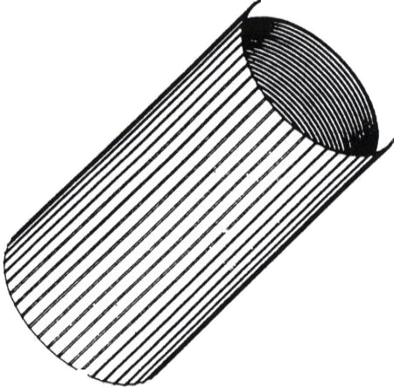

UNIVERSAL ALUMINUM
Conduit Couplers

Aluminum reverse-threaded couplers designed for use with any of innerduct or HDPE conduit types.

• Air-tight for pressurized cable propulsion systems
• Reverse threaded
• Designed for smoothwall, ribbed, or corrugated duct

Sizes and Specifications:
PART# SIZE DUCT O.D. RANGE
SP120 1/2” 0.761” – 0.850”
SP1O1 3/4” 1.011” – 1.150”
SP1O2 1” 1.230” – 1.420”
SP1O3 1-1/4 1.490” – 1.710”
SP1O4 1-1/2” 1.800” – 2.010”
SP1O5 2” 2.310” – 2.520”

INSTALLATION INSTRUCTIONS:
1. Use an innerduct cutting tool to cut the ends of the innerduct squarely. The cut at the end of the innerduct should be at a 90 degree angle to the innerduct wall.

2. Push both ends the innerduct into the aluminum coupler so that the innerduct wall is as parallel as possible to the ridges on the outside wall of the coupler.
3. Turn the coupler in the direction of the arrow on the coupler label using a strap wrench, vice grip, or similar tool.
4. Tighten to 100-150 foot-pounds of torque.

ENDOT INDUSTRIES, INC.
www.endot.com - e-mail info@endot.com

VOICE 800 443 6368 – FAX 973 625 4087
CORPORATE HEADQUARTERS: 60 Green Pond Road, Rockaway, NJ 07866
TENNESSEE OPERATIONS: 400 Bohannon Avenue, Greeneville, TN 37745

OKLAHOMA OPERATIONS: Mid America Industrial Park, Pryor Creek, OK 74361

